**ACCT-001 - Define Secure AWS Account Governance Best Practice**

**The root user is secured**

The Root user has administrative roles, with MFA enabled. Users with access to the Customer's AWS portal have minimal access roles: read only. The CloudTrail application is used to monitor user activity.

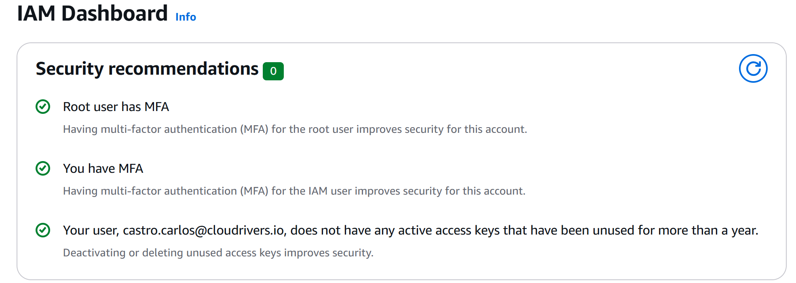

**Using CloudTrail for user event logging:**

